

**SMI-VN Travel Company Limited**

6F, VN Post Building, 271 Nguyen Van Linh St., Thanh Khe Dist., Da Nang, Vietnam

Tel:(84-236) 356 2669

Email : vietnam@smi-group.asia

Wendy Tour Website : https://wendytour.com/vietnam

SMI CENTRAL CAR LIST

～Be My Guest～

2020年03月19日

◎**利用車両一覧**

|  |  |  |  |  |  |  |  |  |  |
| --- | --- | --- | --- | --- | --- | --- | --- | --- | --- |
| Company | Type | Name | Maker | No. of cars | Seats inc. driver | Max No of Suitcase | Max No. guests | | |
| APT TRSF | Golf | S/S |
| **THANH CONG**  **（タンコン）** | 7 seats | Innova | Toyota | 6 | 7 | 2 | 2 | 2 | 4 |
| 16 seats | Solati | Huyndai | 2 | 16 | 6 | 6 | 6 | 9 |
| **TAM DUC**  **（タムドゥック）** | Sedan | Cruz | Chevrolet | 1 | 4 | 2 | 2 | 1 | 2 |
| 7 seats | Innova | Toyota | 2 | 7 | 2 | 2 | 2 | 4 |
| 29-35 seats | County | Hyundai | 2 | 30 | 8 | 8 | 8 | 12 |
| 29-35 seats | Samco | Isuzu | 5 | 35 | 15 | 15 | 15 | 28 |
| 45 seats | Universe, Hi-Class | Hyundai | 5 | 45 | 30 | 30 | 30 | 40 |
| **KIEU LE**  **（キウレー）** | 16 seats | Transit | Ford | 2 | 16 | 6 | 6 | 6 | 9 |
| MIDDLE BUS | County/ SAMCO | Hyundai | 2 | 25 | 8 | 8 | 8 | 12 |
| Thaco Town | Truong Hai Auto | 4 | 35 | 15 | 15 | 15 | 28 |
| 45 seats | Universe | Hyundai | 7 | 45 | 30 | 30 | 30 | 40 |
| **VU NGOC**  **（ヴーゴック）** | 7 seats | Innova, Fortuner | Toyota | 8 | 7 | 2 | 2 | 2 | 4 |
| 16seats | Sprinter | Mercedes | 1 | 16 | 6 | 6 | 6 | 9 |
| Transit | Ford | 7 | 16 | 6 | 6 | 6 | 9 |
| 29-35 seats | County | Hyundai | 2 | 30 | 8 | 8 | 8 | 12 |
| Samco | Isuzu | 2 | 35 | 15 | 15 | 15 | 28 |
| 45 seats | Universe | Hyundai | 3 | 35 | 15 | 15 | 15 | 28 |

**<KIEU LE>**

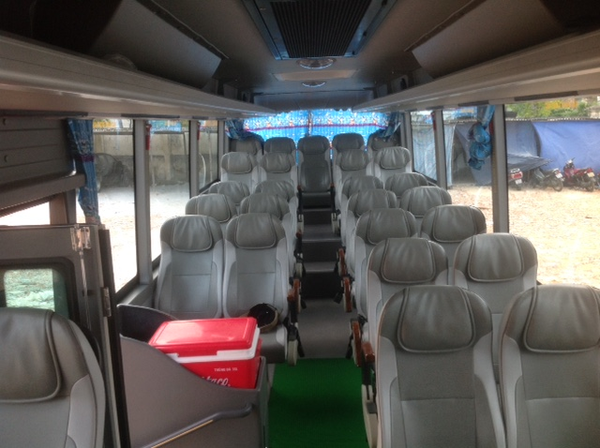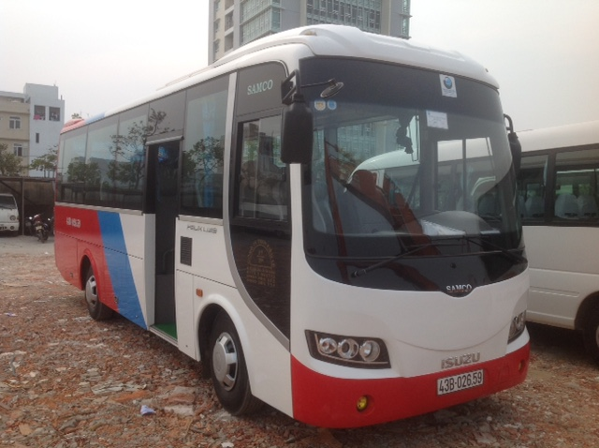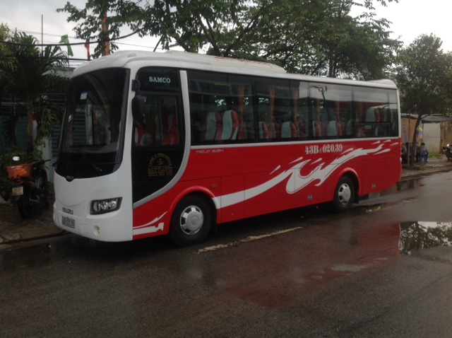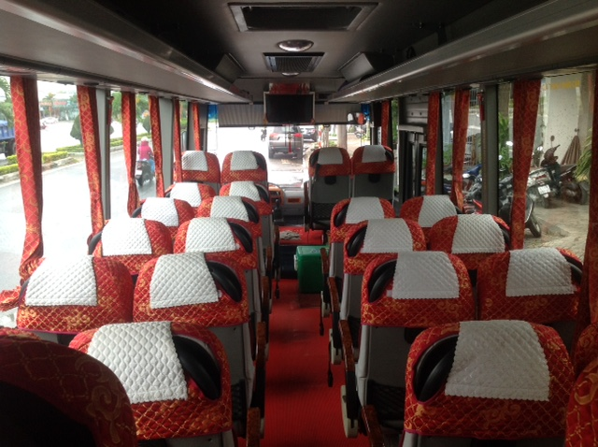 **COUNTY (30 Seats)**

**THACO TOWN / SAMCO (35 Seats)**

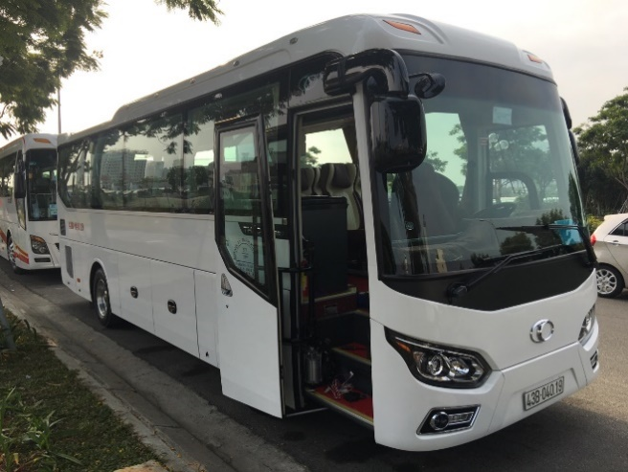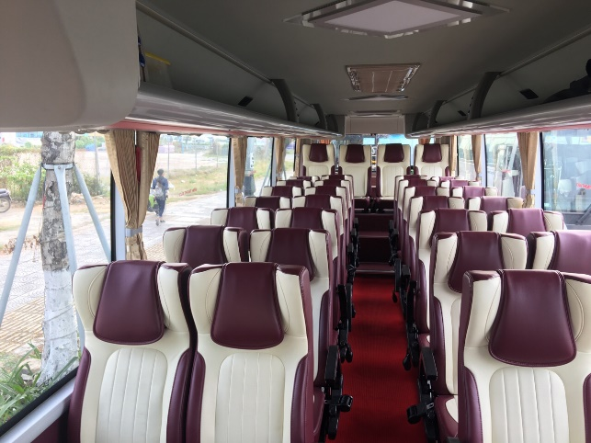

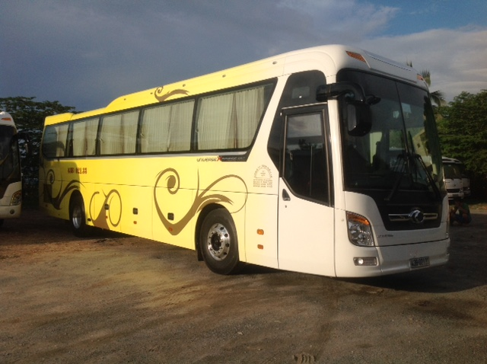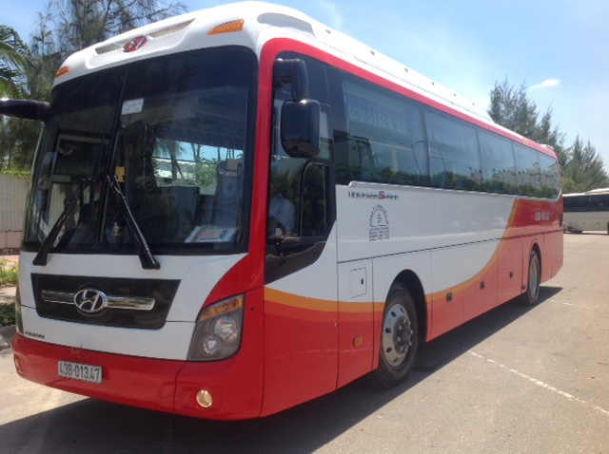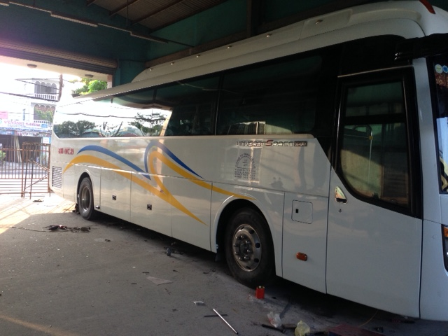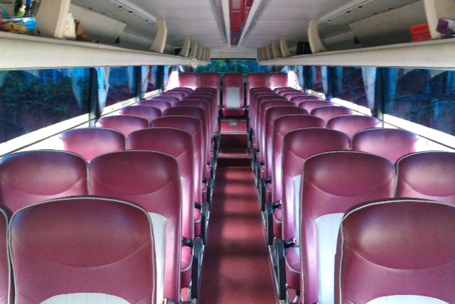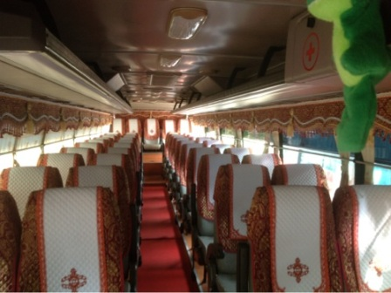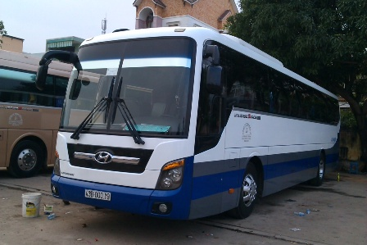**UNIVERSE Hyundai (45 seats)**

**<VU NGOC>**

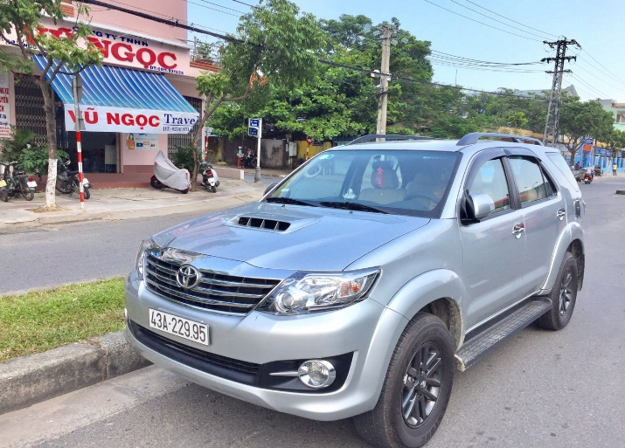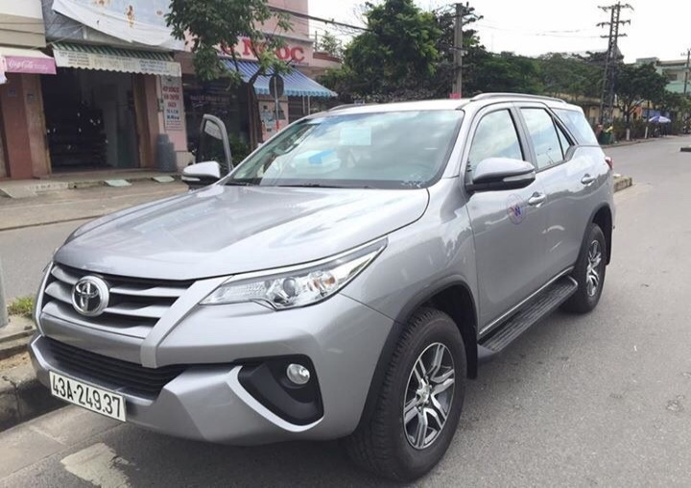**TOYOTA FORTUNER (7 Seats)**

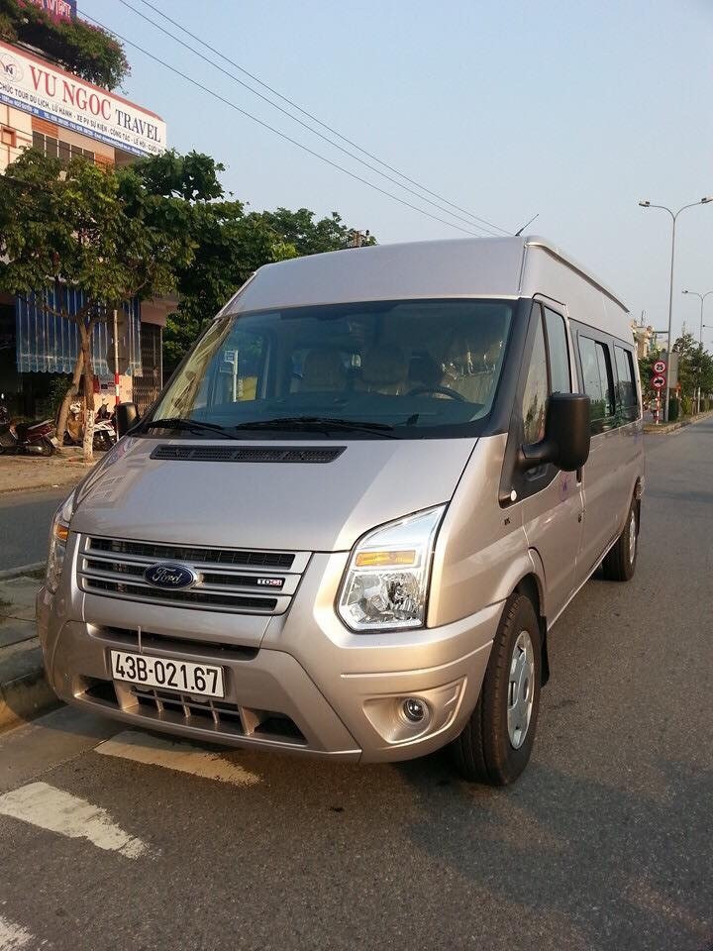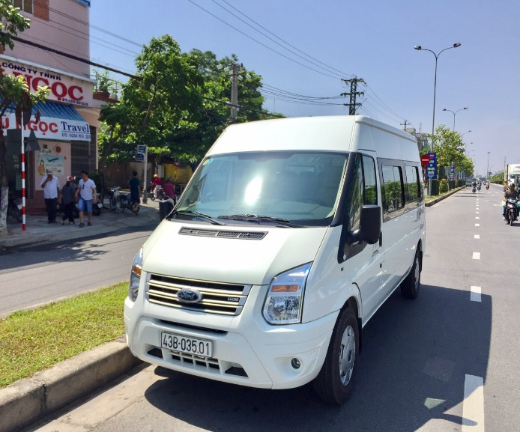**FORD TRANSIT (16 Seats)**

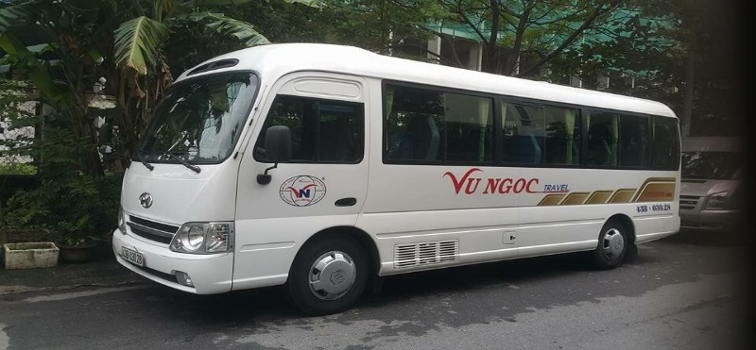**HUYNDAI COUNTY (29 Seats)**

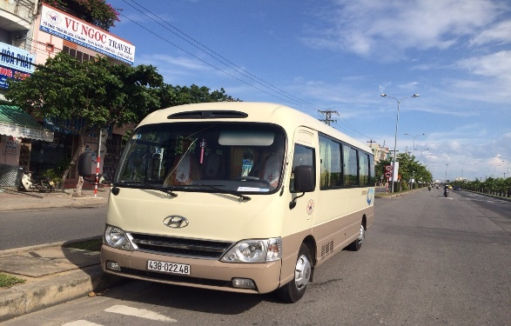

**<THANH CONG>**

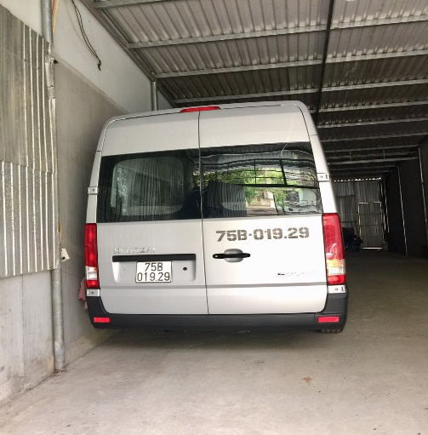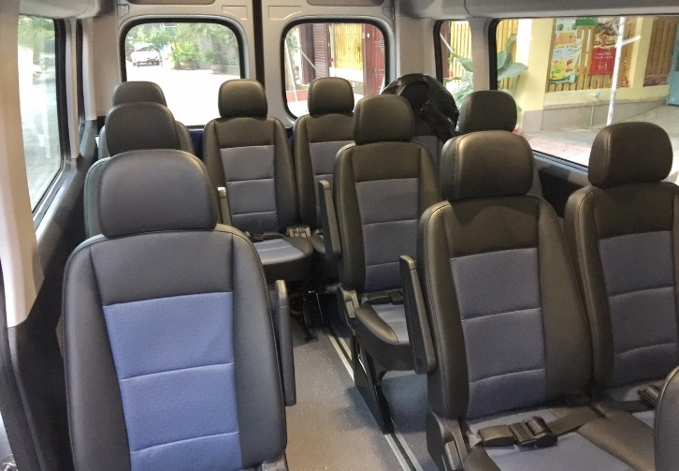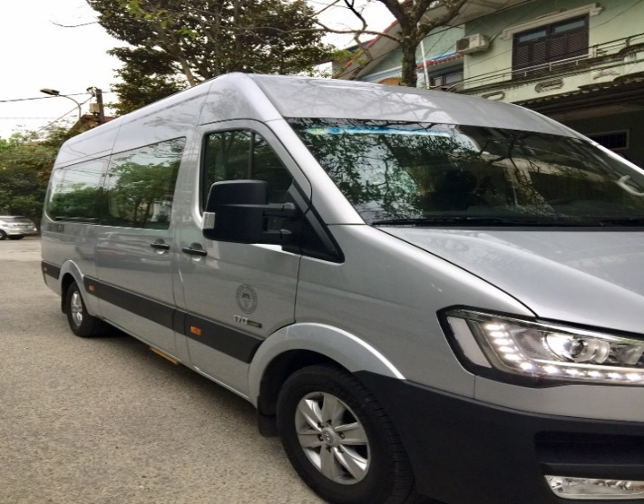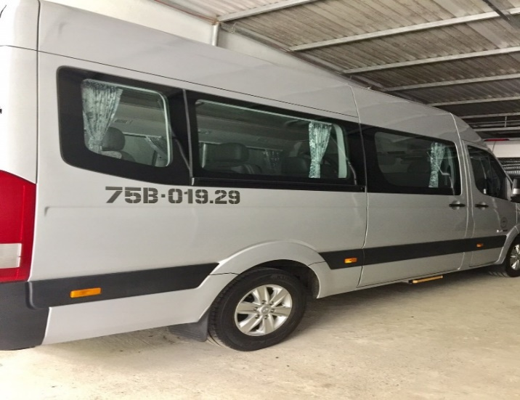**HUYNDAI - SOLATI (16 Seats)**

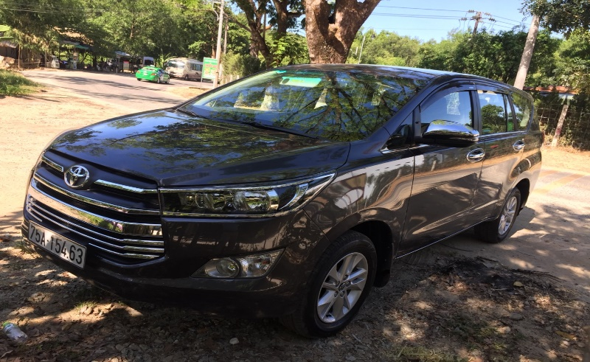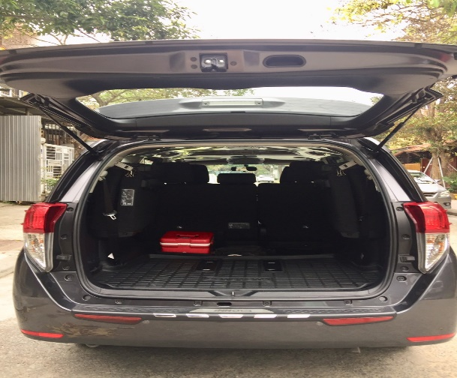**TOYOTA - INNOVA (7 Seats)**

**<TAM DUC>**

**GM - CRUZ (4 Seats)**

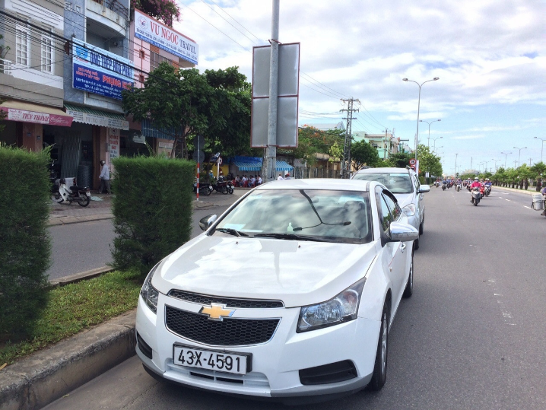

**MERCEDES SPRINTER (16 Seats)**

